Topic: | Custom formulas
Training reference: | Reporting .NET Client – User Manual - p484 - “Custom formulas
Date | 2019/12/02
Version | V1 Creation

- Intro:

- In Tagetik, use custom formula is a method to recover / save data in the database without creating a new matrix.
- /!\ Be careful when you type a formula or when you modify an argument in it the result is not always immediately available. You must refresh custom formulas with the button “Refresh custom functions” in the tab “CCH Tagetik” of the Excel’s ribbon.

- Available Formulas:

- TGKCURRDB
- TGKRET
- and TGKRETF: recovers data from a determined database according to the parameters specified during the function invocation step;
- TGKSEND: recovers a value from a determined database and allows the user to modify and save it again in the database
- TGKFIELD: recovers the value of a cell field
- TGKAMOUNT: recovers the value present on the database according to the filters present on a cell
- TGKCALCSET: allows improving the performance of "complex" forms that contain many custom functions
- TGKOPTION: allows specifying the reporting engine with which to calculate the TGKRET functions

- Formulas in practice:

- TGKCURRDB

- Used to recover the database code the user is currently connected to.
- You must type “=TGKCURREDB()” in one cell. The result of the cell will be the exact name of the database on which you are connected:
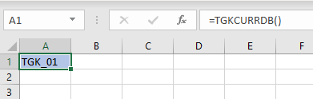
- It’s possible to use directly the formula TGKCURRDB as an argument in another formula:
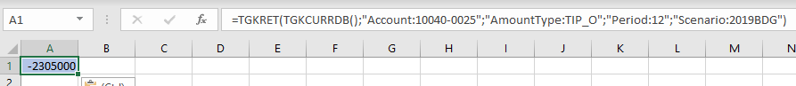

- TGKRET

- Used to retrieve a value from a specific database according to specified filters.
- The basic structure of the formula is:
“ =TGKRET(database, “DimensionName1:Code1”, “DimensionName2:Code2”,…”
- No specified order for the arguments except for the first one the name of the database.
- 4 mandatory dimensions: Account ; AmountType ; Period ; Scenario:
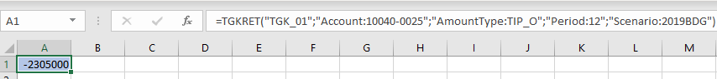
- For instance: same formula with 2 more dimensions
- No specified order for the arguments except for the first one the name of the database.
- 4 mandatory dimensions: Account ; AmountType ; Period ; Scenario:

TGKRET ==» to be continued it’s possible to add some filter in the dimention

- TGKRETF:

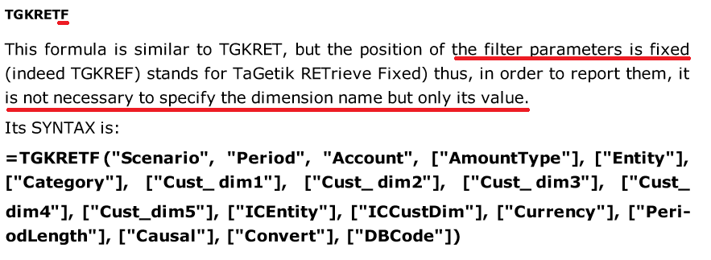

Seems to be more convenient than TGKRET

I noticed that in the demo environment on ABC, the report P&L Retrieve Report is based only on this formula.
No matrix used. But in this case, I guess the structure of the P&L never change or very rarely.

